Task 11

1. Chat GPT

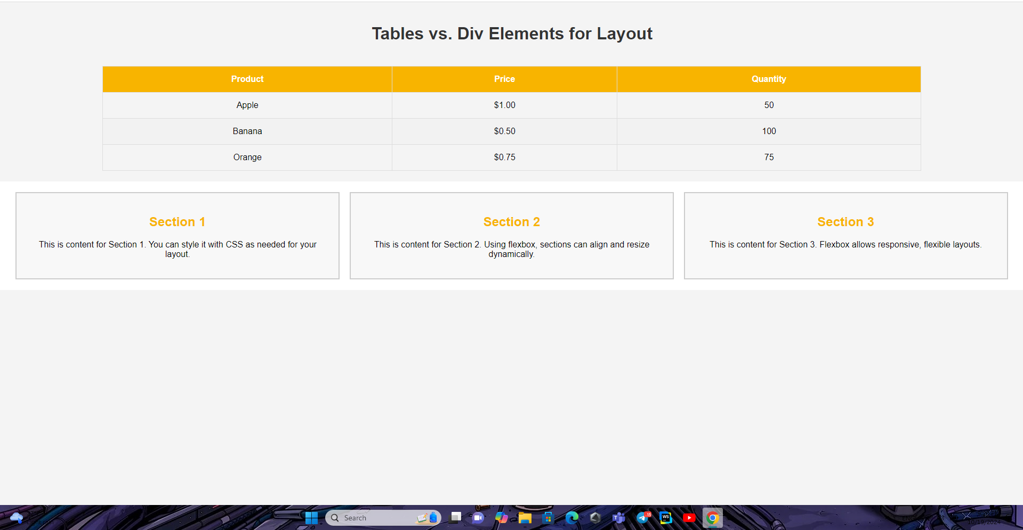

2. Gemini

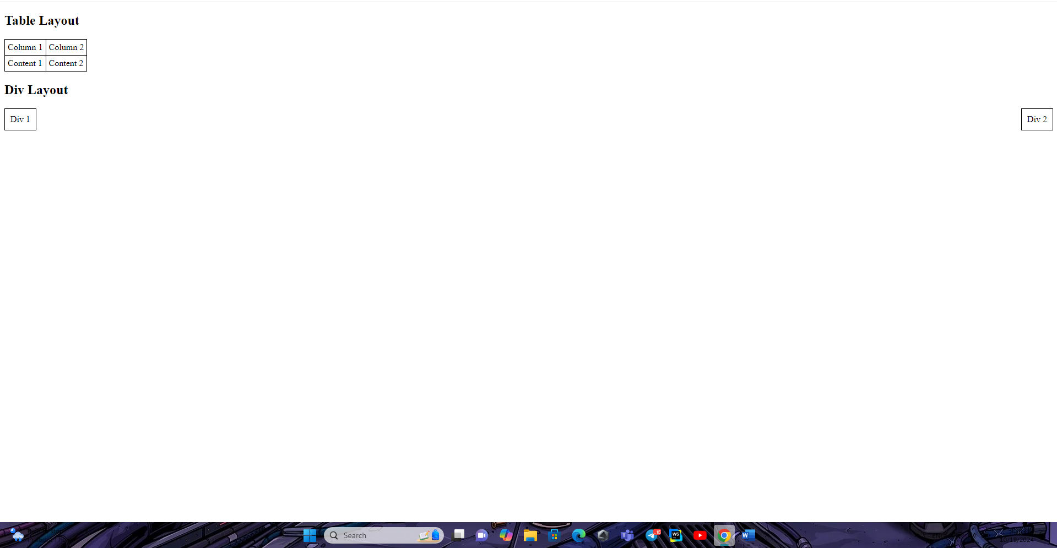

Both follow the prompt. But Chat GPT is lock better.